TITLE
Smart Mini Washing Machine: A Microcontroller‑Based System with Remote User Feedback

AUTHORS
Muhammad Imran Bin Veddin (2316409) , Alya Khairah Binti Khairul Jamil (2317100) , Muhammad Irfan Rushdi Bin Asri (2319011) , Department of Mechatronics Engineering , International Islamic University Malaysia , Email: imrannv04@gmail.com

ABSTRACT
This paper presents the design and development of a manual-assisted smart mini washing machine for educational and small-scale domestic applications. The system is developed as a Mechatronics System Integration project, combining mechanical actuation, electronic control, and embedded programming to automate the washing process. An Arduino-based microcontroller is used to control the washing, rinsing, spinning, and drainage operations through a structured sequence initiated by user inputs. A DC motor driven by an L298N motor driver provides drum motion, while a servo motor controls the drainage mechanism. User interaction is facilitated through push buttons, LED status indicators, a buzzer, and a 16×2 I2C LCD display that provides real-time system feedback and operational prompts. Safety is addressed through an emergency stop function that immediately halts system operation. The developed prototype successfully demonstrates effective system integration, reliable process sequencing, and clear user interaction, making it suitable as a learning platform for embedded systems and automation concepts.

INTRODUCTION
Household washing machines have evolved from simple electromechanical devices to complex appliances expected to be automated, connected, and user-friendly [1]. Traditional low-cost washers typically provide only local control and limited feedback: users must be physically present to start cycles, check progress, and respond to faults such as imbalance, drainage failure, or power interruptions [2]. High‑end smart machines with Wi‑Fi and mobile apps do exist, but they are expensive and often rely on proprietary ecosystems, making them unsuitable for educational use or low-cost retrofitting of existing machines [3].

Recent research shows a strong trend toward smart, IoT‑enabled laundry systems. PLC‑ or microcontroller‑based controllers can fully automate washing, rinsing, and spinning while monitoring water levels, timing, and faults to improve reliability and safety [2]. IoT extensions for public or shared laundry rooms allow users to remotely see machine availability, receive cycle‑completion alerts, and reduce waiting times and overcrowding [4]. Other projects integrate web or mobile interfaces, wireless modules (NodeMCU, ESP8266/ESP32), and payment systems to create pay‑per‑use smart laundry platforms [5].

Building on these developments, this project aims to design and implement a mini smart washing machine prototype using Arduino and ESP32. The system focuses on three core wash modes (wash, rinse, spin), realistic drum control via an L298N motor driver, and a servo‑operated drain mechanism. In addition, it adds safety and connectivity features: an emergency stop that immediately halts operation, a dedicated LCD unit for local status display, and an ESP32‑based Telegram bot for remote, real‑time status notifications. The prototype targets a low‑cost educational platform for teaching embedded control and IoT integration, similar in spirit to washing‑machine trainers and IoT laundry monitoring systems reported in recent literature [3].

2.0 METHODOLOGY
2.1 Project Development
Overall, a block diagram provides a clear overview of the entire system by illustrating the connections between the inputs, outputs, and the microcontroller. The washing machine project consists of three microcontrollers, which are categorized into three subsystems. Fig. 1 shows the block diagram of the first microcontroller, an Arduino, which functions as the Master controller. Fig. 2 presents the block diagram of the second microcontroller, also an Arduino, which is dedicated to controlling the LCD. Fig. 3 illustrates the block diagram of the third microcontroller, the ESP32, which is used for IoT purposes, enabling the monitoring of the washing machine system via Bluetooth on the ESP32 and Telegram on a mobile phone. Finally, Fig. 4 shows the flowchart for the overall system operation.

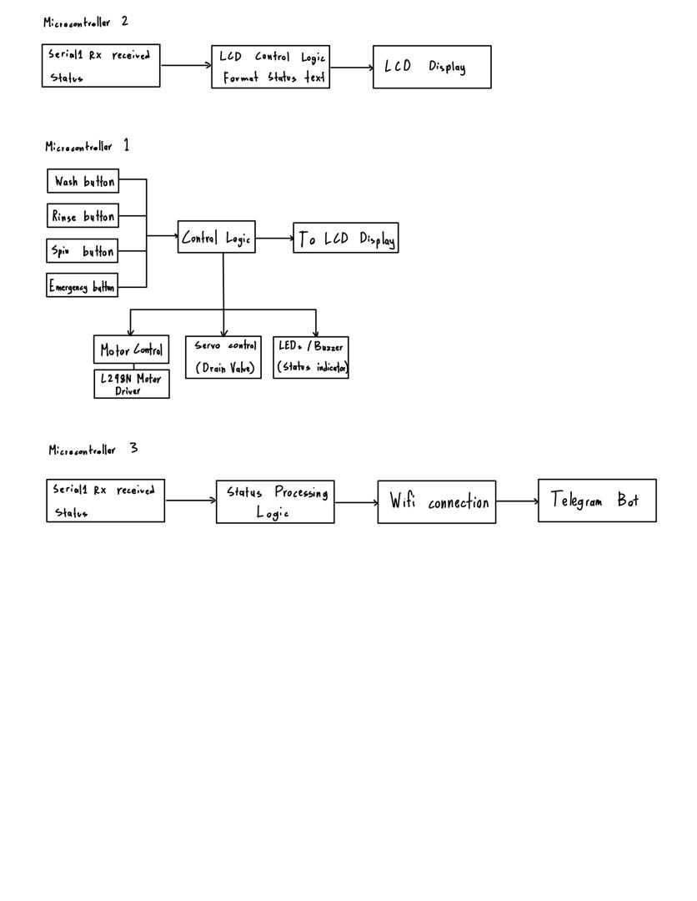
Fig.1 Block diagram of microcontroller 1 (Arduino Mega 2560)

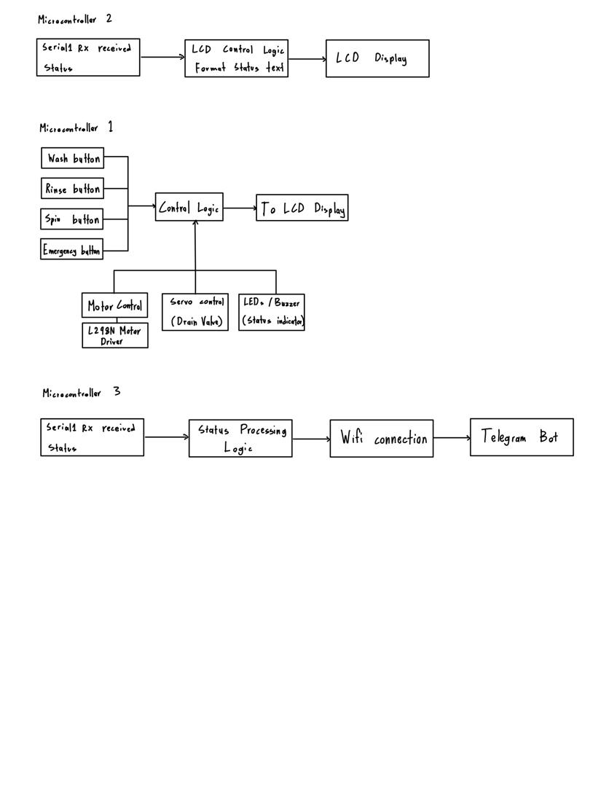

Fig.2 Block diagram of microcontroller 2 (Arduino Mega 2560)



Fig.3 Block diagram of microcontroller 3 (ESP 32)

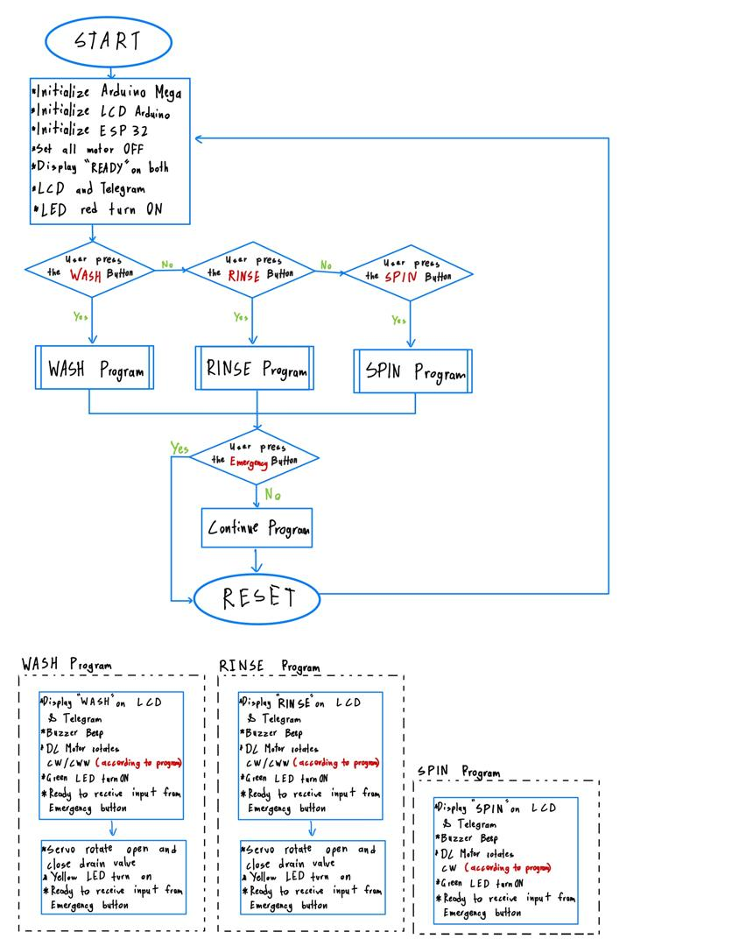

Fig.4 The flow chart that explains all the work principles
2.2 Schematic Diagram and Prototype Setup

The system consists of three microcontrollers working together. The main Arduino Mega acts as the central controller, directly managing the washing machine’s DC motor (via a motor driver), servo motor, LEDs, buzzer, and 4 input buttons through wired connections on the breadboard.
A second Arduino Mega is dedicated to the LCD module, handling all display-related tasks. This Arduino receives system status data from the main Arduino Mega through hardware serial communication using TX1 and RX1, ensuring reliable data transfer without interfering with other peripherals.
The ESP32 is also connected to the main Arduino Mega through a voltage-divider resistor network on the serial communication line (TX2 → RX2) to account for the logic-level difference between the two devices. Since the Arduino Mega operates at 5 V logic while the ESP32 uses 3.3 V logic, appropriate resistor value calculations are required to ensure safe and reliable communication.
Overall, all control and feedback components communicate through wired connections, while the ESP32 serves as the bridge between the system and the wireless network, enabling remote monitoring.

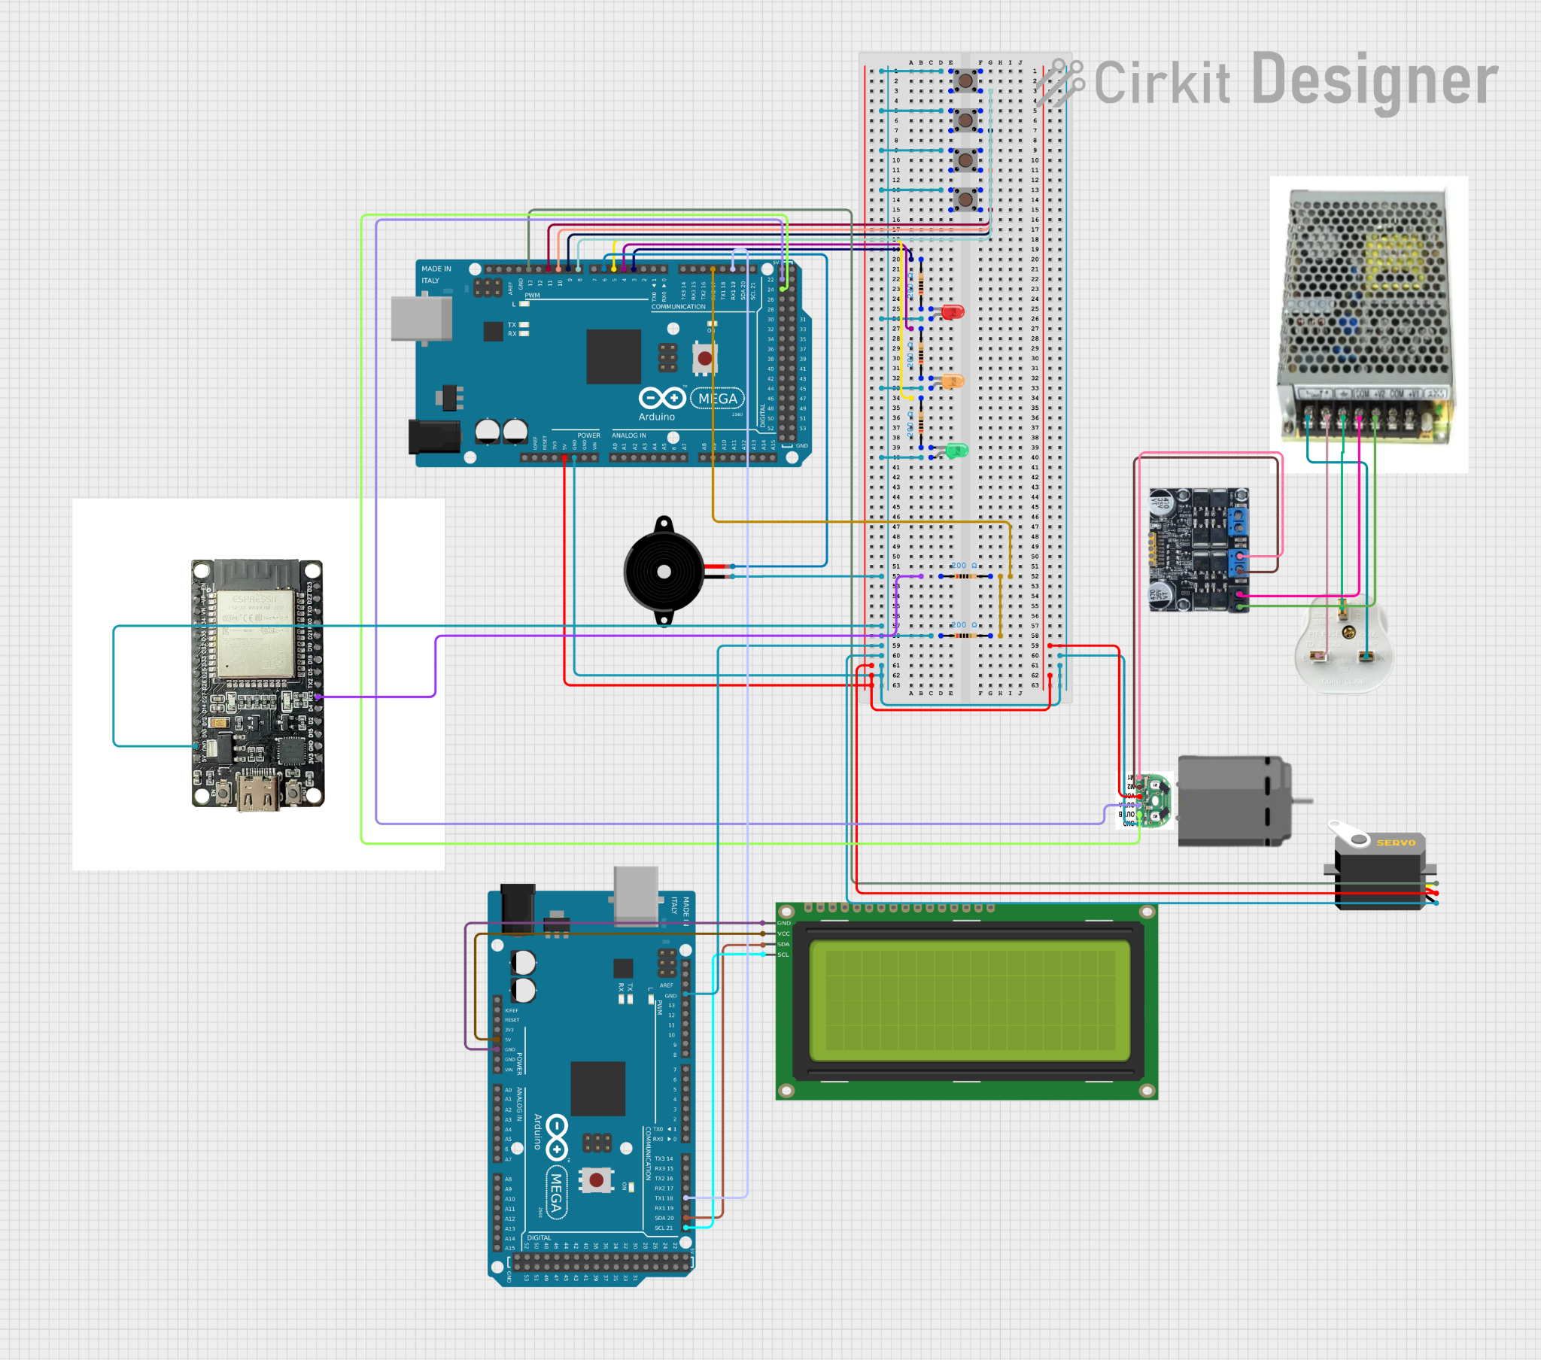
Fig 5
3.0 RESULT AND DISCUSSION

3.1 System 1 (Washing Operation Control System)

System 1 refers to the washing operation control system, which is the core functionality of the mini washing machine. This system is responsible for executing the WASH, RINSE, and SPIN modes based on user input through the push buttons mounted on the control panel. The Arduino Mega functions as the main controller, coordinating the motor, servo drain mechanism, LED indicators, and buzzer to simulate real washing machine behavior.
Experimental observations show that when a specific mode button is pressed, the system responds immediately by initiating the corresponding operation. During the WASH and RINSE modes, the DC motor alternates between clockwise and counter-clockwise rotation, representing the agitation process. This alternating motion was observed to be consistent throughout the programmed duration, indicating stable motor control through the L298N motor driver. In addition, the DRAIN process is automatically triggered after the washing and rinsing cycles, where the servo motor opens the drain valve to allow water discharge before closing again after the set time interval.
The SPIN mode demonstrates high-speed unidirectional motor rotation, which represents the water extraction phase in a real washing machine. The green LED remains illuminated throughout normal operation, indicating an active process, while the buzzer produces an audible alert at the beginning and completion of each cycle. Based on repeated trials, all operational modes completed successfully without unexpected interruptions, proving that the programmed logic and timing control are reliable. Overall, the results confirm that System 1 performs effectively in simulating realistic washing machine operations under normal conditions.

3.2 System 2 (Emergency Stop and Safety System)
System 2 focuses on the Emergency Stop and safety mechanism, which is designed to protect the system and user in the event of an abnormal condition. This system is activated when the emergency stop button is pressed during any operational mode. Upon activation, the Arduino Mega immediately halts all motor activity, closes the drain valve using the servo motor, and switches the system status to an emergency state.

Experimental testing indicates that the emergency response is instantaneous, with the motor stopping within a very short time after the button is pressed. The red LED is activated to visually indicate the emergency condition, while the buzzer and normal operation LEDs are disabled. At the same time, the system sends an “EMERGENCY” status message to both the LCD display and the Telegram monitoring system. This rapid response ensures that the system enters a safe state and prevents further mechanical operation until the emergency condition is cleared.
After the emergency button is released, the system resets itself and returns to the READY state, confirming that the recovery mechanism functions correctly. These results demonstrate that the emergency system is stable, responsive, and capable of providing reliable protection during unexpected events.

3.3 System 3 (Monitoring and Notification System)

System 3 represents the monitoring and notification system, which integrates an LCD display and an ESP32-based IoT module to provide real-time feedback to the user. The LCD module continuously displays the current washing machine status, such as READY, WASH, DRAIN, SPINNING, DONE, and EMERGENCY, allowing users to easily monitor the progress of the washing cycle.
In parallel, the ESP32 receives status messages from the main controller and forwards them to a Telegram bot via WiFi. Test results show that each change in system state is successfully transmitted and received on Telegram within a short time interval. Messages such as “Washing Machine Status: WASH”, “SPINNING”, and “DONE” were delivered reliably without duplication due to the implemented status comparison logic.
The stability of the wireless communication was tested across multiple operation cycles, and the system consistently delivered accurate notifications. This confirms that the monitoring system provides an effective remote awareness feature, allowing users to track the washing process even when they are not physically near the machine.

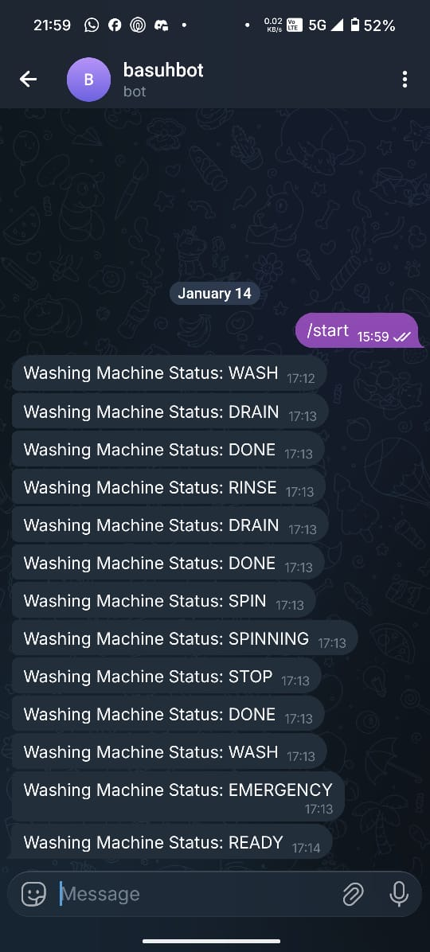
Fig 6

3.4 Overall System Performance
Based on the results obtained from all subsystems, the mini washing machine project demonstrates reliable performance, good system integration, and effective safety handling. The coordination between mechanical components, visual indicators, audio alerts, LCD display, and IoT notification system highlights a well-structured embedded system design. The successful execution of washing operations, rapid emergency response, and real-time Telegram updates confirm that the system meets its intended objectives and simulates a smart washing machine effectively.

4.0 CONCLUSION
This project successfully developed a mini smart washing machine prototype that integrates automated wash, rinse, and spin cycles with safety and connectivity features. Using an Arduino Mega to control the motor, LEDs, buzzer, and drain servo, the system can execute predefined programs with agitation, spin, and draining sequences. An additional Arduino with an I2C LCD provides real-time status display, while the ESP32 module enables Wi‑Fi connectivity and Telegram notifications, allowing remote monitoring of the machine’s operating state.

The implementation of an emergency stop button with immediate motor shutdown and status broadcasting enhances user safety and system reliability. Overall, the prototype demonstrates how low-cost microcontrollers and simple communication protocols can be combined to create a compact, semi‑autonomous washing system suitable for educational and small‑scale household applications. Future work could include adding water level sensing, load detection, automatic detergent control, and a mobile app interface to further improve usability and efficiency.

Acknowledgement

We would like to thank the Mechatronics System Integrations laboratory staff for providing the necessary components and technical support for this project.

Conflict of Interest

We declare that there is no conflict of interest regarding the publication of the paper.


Author Contribution
Signature: |  | Read | /
Name: | MUHAMMAD IMRAN BIN VEDDIN | Understand | /
Matric Number: | 2316409 | Agree | /
Contribution: | Methodology

Signature: |  | Read | /
Name: | ALYA KHAIRAH BINTI KHAIRUL JAMIL | Understand | /
Matric Number: | 2317100 | Agree | /
Contribution: | Results and Discussion

Signature: |  | Read | /
Name: | MUHAMMAD IRFAN RUSHDI BIN ASRI | Understand | /
Matric Number: | 2319011 | Agree | /
Contribution: | Abstract , Introduction and Conclusion

REFERENCES
[1] Aheleroff, S., Xu, X., Lu, Y., Aristizábal, M., Velásquez, J., Joa, B., & Valencia, Y. (2020). IoT-enabled smart appliances under industry 4.0: A case study. Adv. Eng. Informatics, 43, 101043. https://doi.org/10.1016/j.aei.2020.101043.
[2] Yang, L., Cai, Y., & Cao, J. (2025). Automatic Washing Machine Control System Based on PLC. Frontiers in Computing and Intelligent Systems. https://doi.org/10.54097/889nn890.
[3] Setthawong, P., Triyason, T., Osothsilp, A., & Chinggungval, T. (2022). Cost-Effective IoT Extensions for Existing Public Coin Operated Washing Machine Towards Smarter Apartment Complexes. Current Applied Science and Technology. https://doi.org/10.55003/cast.2022.02.23.001.
[4] Shakya, S., Bajracharya, O., Padmanabhuni, R., Senadeera, S., Taparugssanagorn, A., & Dailey, M. (2021). An Internet of Things System for a Laundry Monitoring Service. 2021 Fifth World Conference on Smart Trends in Systems Security and Sustainability (WorldS4), 235-240. https://doi.org/10.1109/worlds451998.2021.9514042.
[5] Qiao, Y., Zhang, C., Li, R., & Liu, Z. (2019). A Wireless Intelligent Business Laundry Service System. Journal of Computer and Communications. https://doi.org/10.4236/jcc.2019.77011.
[6] Cirkit Designer. (n.d.). Cirkit Designer – Online circuit design and simulation tool. Retrieved Month Day, Year, from https://www.cirkitdesigner.com
[7] Arduino. (n.d.). Arduino Mega 2560 board overview and technical specifications. Retrieved January 19, 2026, from https://docs.arduino.cc/hardware/mega-2560
[8] Espressif Systems. (n.d.). ESP32 series datasheet. https://www.espressif.com/en/products/socs/esp32
[9] How To Mechatronics. (n.d.). L298N motor driver – Arduino interface, specifications and example.https://howtomechatronics.com/tutorials/arduino/arduino-dc-motor-control-tutorial-l298n-pwm-h-bridge/

